**Bilateral Trade Analysis & Market Intelligence Report**   
(China and Hungary, 2020–2024)

**Table of Contents**

Bilateral Trade Trends (2020–2024) 1

General trend 1

Trade Structure Analysis 3

Change overtime 4

RCA Analysis 4

Trade Intensity Index 6

Market Intelligence Conclusion 7

Appendix A: Screenshot of Data Source 8

Appendix B: Excel file data with data and calculation 8

**Bilateral Trade Analysis & Market Intelligence Report**

The bilateral trade is the trade between two countries wherein goods and services are exchanged based on mutual agreement, market conditions and comparative advantages (Hammer & Faye, 2006). It allows the countries to specialise in producing goods, which they are most efficient and import products, which are produced in other countries more efficiently. In this work I reviewed the bilateral relationship between China and Hungary in terms of trade flows looking at bilateral indicators of trade flows, most exported goods, and comparative advantage. In order to do that, I used 5 sets of data (*WorldwideExport, BilateralChinaHungary, ChinaWorldExport, HungaryWorlImport, WorldImports*) obtained through (UN Comtrade, 2024), which contained information on Chinese exports to Hungary, Hungary imports structure, and the data regarding the product level that allowed me to estimate Revealed Comparative Advantage. With the above datasets, I sorted the information, created pivot tables, calculated the Trade Intensity Index and provided the result in a charted format.

# ****Bilateral Trade Trends (2020–2024)****

To begin with, I analysed the trend of the exports of China to Hungary within the period of the year 2020 to 2024. To show how the relation has been developed, I calculated the sum of bilateral annual export and plotted a line chart to illustrate it. The chart served to comprehend the manner in which the performance of Chinese exports has been changing over the period of time.

## General trend

The bilateral trade dynamics between China and Hungary indicates a number of meaningful changes due to the global shocks like the COVID 19 pandemic, supply-chain shocks, inflationary pressures and recovery trends in the EU market. Using the obtained UN Comtrade data, the pattern of export flows of China to Hungary (in FOB values) per year shows the same tendency similar to the world trends of manufactured goods and high-technology products.

In 2020 to 2024, export of China to Hungary tended to grow, but the growth rate was fluctuating. This was because the outbreak of the COVID-19 pandemic in 2020 shook supply chains, decelerated transportation networks and demand in the European markets. In Hungary, there was a slowing down in the production process as the factories were either closed down or working at a low level. As a result, the exports of China to Hungary were at the lowest point during the time period under observation. The state of affairs started improving at the end of 2020 when China has reinstated its manufacturing activities more rapidly than most other economies, still, the disruptions were extensive.

In 2021, the trade relationship became much stronger. With Europe in place with reopening policies, and the industrial production going back to business, Hungary imported more machinery, electronics and components. The semiconductor shortage of 2021 and 2022 accelerated the search of alternative suppliers and China was a major manufacturer of electronic components, telecommunication equipment and intermediate goods to be used in the assembly of automotive vehicles. This helped to achieve a significant recovery in the bilateral trade volume.

The trend persisted in 2022 and 2023, and the exports of China to Hungary increased continuously. The Hungarian industry grew in this time, which was in part because of more foreign investments in electric-vehicle batteries production, electronics manufacturing facilities and automotive assembly factories. With these industries being very dependent on imported machineries, electrical parts, processed materials, the role that China plays as a supplier became more visible. Constant growth in the trade volumes was a result of the long-term growth of these sectors.

By the year 2024, the bilateral trade relationship had stabilised to a relatively high point. This growth rate was more moderate than the one witnessed in the past years, partly as a result of inflationary pressures in Europe and slower general industrial production in the EU. However, the volume of trade between the two countries was still high and indicated that the Chinese manufactured goods were still in constant demand. In general, it is evident that over the five-year period there was an obvious trend that even though the global situation was creating temporary disruptions in the trade relationship, it was intensifying and extending with China solidifying its role as one of the key suppliers to the Hungarian industrial industry.

# ****Trade Structure Analysis****

The export structure of Chinas to Hungary is skewed towards manufactured goods, machinery, electronics and industrial inputs. The data on the last year (2024) reveals that the highest export items to Hungary were *electrical machinery and equipment and parts thereof; sound recorders and reproducers; television image and sound recorders and reproducers, parts and accessories* (HS 8517) with a value of products worth $5,224,906,344, followed by Telephone sets, including smartphones and other telephones for cellular.

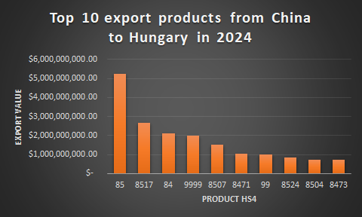

Hungary is generally a good car manufacturing location with several European and global automakers having production plants in Hungary. Consequently, it brings in large volumes of components, wiring sets, mechanical and electronic modules and mechanical parts into China. The other products that have become significant to Hungary include plastics, chemical products and technical instruments, as Hungary is also involved in the chemical processing, electronics assembly and medical technology industries.

## Change overtime

These exports have changed in structure over time. During the 2020-2024 period, the proportion of low-value consumer goods (clothing and footwear) fell, whereas high-technology and industrial products took a significant upward trend. Such a change is indicative of a larger change in the global export pattern of China, which is slowly changing to more of a manufacturing goods export rather than labour intensive products. The growing integration of Hungary into the global chains of supply has generated a long-term need of importation of the technologically advanced parts which will also strengthen the role of China as the significant supplier.

New product lines have also been formed recently. Battery components, particularly in the lithium-ion technology, are one of the fastest developing groups through the dynamic electric-vehicle battery production industry in Hungary. Telecommunications equipment has also been in the limelight and this has been as a result of the investment on digital infrastructure and capacity of the networks. Moreover, plastics and chemical feeds employed in automobile and electronic production have become the main focus. This is a good indication of the fact that there is a good future in that there can be an increase in industrial collaboration between the two nations.

# ****RCA Analysis****

I selected five HS4 product categories and calculated the Revealed Comparative Advantage (RCA) index using Balassa’s formula to determine if a country (China) has a comparative advantage in producing or exporting that product.

$RCA=\frac{\frac{X_{i,j}}{X_{i}}}{\frac{X_{w,k}}{X_{w}}}$ here $X_{i,k}​ = China’s world export of product k$, $X_{i}​ = China’s total world exports$, $X_{w,k}​ = World export of product k$, $X_{w}​ = Total world exports$ and if $RCA > 1 = the country has comparative advantage$

I then did these calculations in Excel ("*calculations sheet*") and the result of the products were as follows

|  |  |  |
| --- | --- | --- |
| Product Category | HS Code | RCA |
| Honey; natural | 3046 | 0.000160 |
| Pig/boar bristles & waste | 4090 | 0.0000919 |
| Pig/boar bristles & waste (variant) | 5021 | 0.000370 |
| Fish/crustacean waste | 5119 | 0.0000271 |
| Pineapples, fresh or dried | 8043 | 0.00000220 |

All the RCA values of the agricultural or animal-based products I selected are far below 1 and this concludes that that China does not possess a comparative advantage in any of them.

The findings are fully in line with the global export structure of China. China does not export major agricultural products, animal by-products or fresh fruits. Its industrial sector is specialising in the production of manufactured products, sophisticated machinery, electronic and processed materials. Consequently, primary goods and crude farm items contribute a small part in its export. The values of the RCA thus represent structural realities in that China does not compete globally in those attributes and these are not part of the trade relation of China with Hungary.

In case of these values over time, it is clear that these RCA indices are not varying much since the production and export capacity of China in these sets of products are structurally constrained. Although there may be slight deviations on a year-to-year basis as a result of fluctuation in agricultural production or weather-related factors, these are not the aspects that alter the comparative disadvantage that China has in these products. Therefore, the RCA analysis can substantiate that the strengths of China in exports are overwhelmingly in the line of manufactured products as opposed to primary goods.

# Trade Intensity Index

The TII measures the importance of bilateral trade relative to each country’s share in world trade. My calculation through Excel using the reference formula: $TII=\frac{\frac{X_{ij}}{X_{i}}}{\frac{M_{j}}{M_{w}}}$ 
 , $X_{i,j}​ = China’s exports to Hungary$, $X_{i}​ = China’s exports to world$, $M_{j}​ = Hungary’s imports from world$, $M_{w}​ = Total world imports$

The trade between China and Hungary was found to be 0.0859 implying that these two countries do not trade as often as they should considering their sizes and their share of trade around the world. This does not imply that this trade relationship is not significant in the absolute but simply that it is not as salient as compared to the overall global trading trends of each country. The export base of China is highly geographically dispersed with great variety in the world, and Hungary is a high importing country to other EU countries as a result of the proximity to its geographical location and the similarity of its regulations. Consequently, the bilateral trade intensity automatically seems to be low although the volumes of trade seem to be large.

Under the 2020 -2024 scenario, bilateral trade intensity is likely to see moderate growths in the next three years of recovery between 2021-2023, as Hungary becomes more dependent on Chinese electronic parts and devices. Thus, the TII outcome demonstrates that the relationship between China and Hungary is favourable, but not highly integrated trade relations.

# Market Intelligence Conclusion

The general discussion of the trade flows, export structure, comparative advantage and trade intensity indicate that there are a number of products that provide great prospects of increased export presence of China in Hungarian market. The first category that has a high growth potential is electrical machinery and equipment under (HS 85). This industry has telecommunications devices, sensors, batteries, electrical equipment and other electronics. The fast progress of Hungary in the sphere of the production of electric-vehicle batteries and the constant investment in the telecommunication sector and the development of digital infrastructure guarantees the further demand of Chinese electrical machinery. The fact that China has become very competitive in this category over the world also supports its prospects of becoming a good growth area in the long run.

The second promising segment is machinery and mechanical appliances. The Hungarian industrial market depends mostly on the imported equipment to assemble automobiles, produce electronics, process chemicals and other industrial outputs. The scale, technological potential and competitive price have also made China a big player in terms of industrial machinery suppliers in the world. The high correspondence between the needs of Hungary and the manufacturing capabilities of China makes this industry a stable contributor to the bilateral trade development.

A third group which has a significant potential is the plastics and chemical products. The automotive, packaging and electronics sectors in Hungary need high volumes of processed plastic materials, polymers and chemical compounds. China is a leading manufacturer of these materials in the world and the demand in Hungary will stand to increase with increase in industrial production. This category is very appropriate in the expansion of trade in the future because of the increasing demand and the established production base of China.

# References

Hammer, S. A., & Faye, D. (2006). A world trade model with bilateral trade based on comparative advantage. *Economic Systems Research, 18*(3), 281-297.

UN Comtrade. (2024). *International Trade Statistics Database.* Retrieved from https://comtradeplus.un.org

Giovannetti, G., Marvasi, E., & Ricchiuti, G. (2023). The future of global value chains and international trade: An EU perspective. *Italian Economic Journal*, *9*(3), 851-867.

Di Giovanni, J., Kalemli-Özcan, Ṣ., Silva, A., & Yildirim, M. A. (2022). *Global supply chain pressures, international trade, and inflation* (No. w30240). National Bureau of Economic Research.

TRADE, O. (2023). International Trade in the Wake of Multiple Shocks. *POLICY*, (277).

Hanson, G. H., & Robertson, R. (2008). *China and the manufacturing exports of other developing countries* (No. w14497). National Bureau of Economic Research.

# Appendix A: Screenshot of Data Source

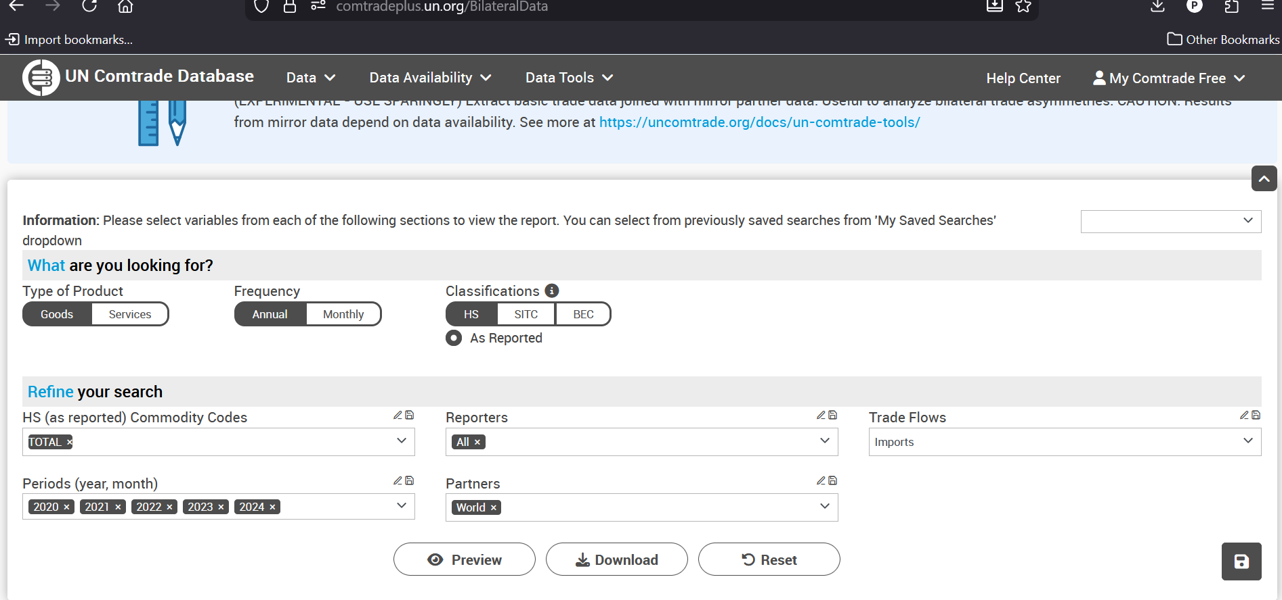



**Note:** *Since I had no premium subscription, any large data set that was having over 100,000 records was downloaded into parts and later append to each other later during cleaning and analysis.*

# Appendix B: Excel file data with data and calculation

